Project Progress Report

Contactless Multi-sensor System for Gesture Recognition

Project Members: Bin Hu, Song Yang, Xin Yang, Zhenzhe Lin

**Objective**

* Achieve a hand gesture recognition system using inaudible signal and ambient light intensity based on the Raspberry Pi.
* Test our system with 10 different gestures under different illumination conditions.

**Current Progress**

* We implemented a prototype for gesture recognition with two speakers, two sound sensors (microphones), and four light sensors (photoresistors). Fig 1 shows the experiment setup. The sensors work well during the experiment.
* 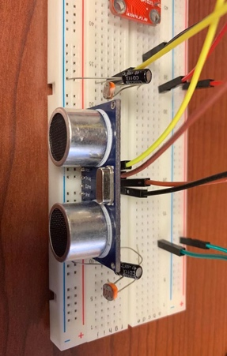We collected data for 10 different gestures on three different scenarios, including indoors with regular illumination, indoors with fluorescent lamp, outdoors with regular illumination. Fig 2 shows the definition of 10 gestures defined in this project.

Fig 1 Experiment setup Fig 2 Gesture definition

**Encountered Problem**

* For the data preprocessing, it is hard to segment the gestures from raw sensor readings corresponding to the ground truth due to the existing ambient noises.
* The statistic features we extracted from chirp signals in time domain could not successfully differentiate the 10 different gestures based on our SVM classification results.

**Solution**

* We plan to try denoising techniques such as DWT (discrete wavelet transformation) to remove the environment inferences from chirp signals before doing the segmentation.
* Instead of analyzing the data in time domain, we consider using FFT (fast flourier transformation) to convert the signal to frequency domain. Based on that, we would extract some features such as PSD (Power Spectral Density) to differentiate the gestures.